Direct Marketing Channels
Options and Opportunities
According to the Consumer Expenditure Survey of the U.S. Bureau of Labor Statistics, the typical U.S. household spent $3,753 on groceries and $2,619 on food away from home in 2009. As a small to mid-scale family farmer you can capture some of those dollars by adding value to your agriculture or horticulture products through direct marketing opportunities.

Selling Directly to Customers
If you are a new market farmer, direct-to-customer-retail marketing is a great way to get started. You have to be a good planner, have time and enjoy meeting and talking to people.

Farmers’ Markets
Direct to the consumer through farmers’ markets is the way many farmers begin selling, because of the low startup costs. Farmers’ markets can provide a low risk opportunity for new farmers to: try new products, build a customer base, increase marketing methods, refine people skills and promote the business brand.
Points to Consider:
- Tend to be seasonal
- Farmers generally receive retail prices or higher for their products
- Vendor startup costs can be very inexpensive
- Collaborative selling attracts more customers
- Have competitive price pressures from fellow vendors
- Increase time spent away from production
Havelock Farmers’ Market, Lincoln NE

Farm Stands
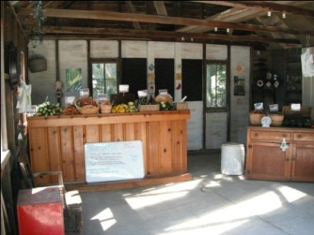
Customers who stop and shop at roadside stands like to see colorful plantings, neat crop gardens, healthy animals and old farm tool displays. Farm stands tend to be located on the farm, on a well-traveled road with good access/parking.
Points to Consider:
- Can be in operation seasonally or all year depending on offered products
- Need quality displays of produce
- Roadside markets usually charge near retail prices
- Clean & wash produce before selling and encourage customers to wash
- Farm stands/markets are structures and may be subject to local building codes and highway setback regulations/signage
Robinette Farm Stand, Martell NE
U-Pick Farms
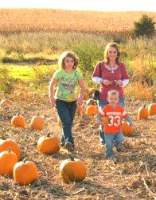
Pick-Your-Own farms grow crops specifically to be harvested by customers. This type of direct sales appeals to individuals and families who want to experience “where their food comes from”.
Points to Consider:
- Priced received is often very close to retail
- Selling your crops through u-pick farms can save you work
- Potentially hurt your crop if customers do not know how to pick properly
- Opportunity to educate your customers about your crops & how to handle crops correctly
Bloom Where You’re Planted Farm, Avoca NE

CSA – Community Supported Agriculture
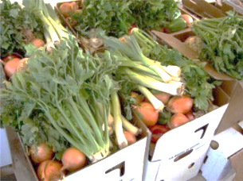
Community Supported Agriculture or CSA’s are about creating a relationship between farmers and consumers where the bounties and risks are shared. CSA customers purchase shares for a season by paying a fee in advance and in return they receive a regular (weekly) selection of food.
Points to Consider:
- Having cash in advance provides financial security for the producer
- Shared risk of low production and crop failures eases strain
- Shared benefit of food strengthens the farmer-consumer bond
Common Good Farm, Raymond NE
- Opportunity for consumer education about your agricultural practices

Agritourism
Agritourism appeals to customers who want to visit a farm and experience its activities. Options include: on-farm bed and breakfasts, Christmas trees, corn mazes, pumpkin patches, petting zoos, festivals, school tours and catered parties.
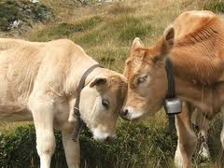
Points to consider:
Chisholm Farm, Bellwood NE
- Your operation can also be blended with other direct marketing techniques
- You can charge a fee
- Can involve other farmers in the area
- Opportunity to educate visitors about agriculture
- Economic potential for your rural community

Restaurants
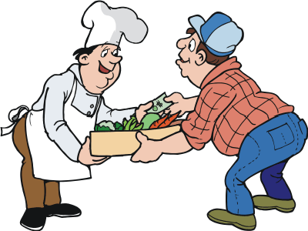
As local restaurants are starting to cultivate relationships with farms for high quality, local food, many producers are starting to market directly to restaurants. Selling directly to restaurants eliminates steps in the market channel, which adds to your product value.
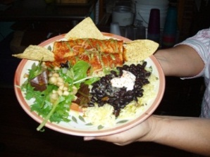
Points to Consider:
- Eliminate the middlemen but you assume the associated costs
- May not be able to charge full retail price
- Restaurants may note your farm and products on their menu
- Chefs demand the same consistent quality and service of a wholesaler from you
- Responsible for invoicing, which must meet restaurants requirements
Pepe’s Restaurant, Lincoln NE

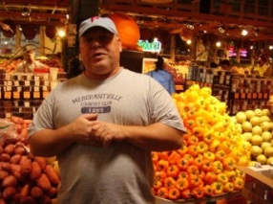
Grocery Stores and Co-op
Many of our local independent grocers, indoor year round farmers’ markets, health food stores and co-op stores are purchasing locally grown food.
Points to Consider:
- Demand the same consistent quality and service of a wholesaler from you
- Partial cases, clean produce, frequent delivery schedules, convenient ordering and expert advice. (See the restaurant section for further information.)

Home Delivery
With home delivery consumers value the convenience offered and believe the products are superior to other outlets.
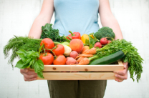
- Requires additional time, transportation costs, strong advertising, catalog and reliable delivery system
- Consumers enjoy keeping in touch with the farmer they purchase from
- You can combine with a CSA

Online Selling to Consumers
Online selling directly to consumers requires time, patience, technology and an user-friendly outlet. Some producers choose to sell through organizations, giving them the benefits of online selling without the hassle of managing a website.

Nebraska Food Cooperative Inc.
Nebraska Food Cooperative Inc. is a year around marketing and distribution service designed to improve market access for farmer producers and local food access for consumers. www.nebraskafood.org
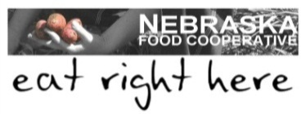
Points to consider:
- Distribution system were the consumers place orders on-line
- Membership fee
- You set your own prices
- Reduce your time and cost of marketing and distributing your products
- Retain your farm identity

Wholesale Selling
Wholesaling through a distributor gives you access to a variety of business customer and saves you time and expense in finding customers.
Points to Consider:
- They set the price
- You will have additional cost: product liability insurance, invoicing, additional labor, additional equipment for picking, grading, cleaning, packaging, labeling,
- Price you receive for your product may fluctuate with the market
- Good choice if you have limited time for face-to-face meetings
- May not get paid immediately as in direct marketing
- Can market large quantities at one time
- Need to grow large quantities and guarantee the delivery of the contract

Farm to School and Institutions
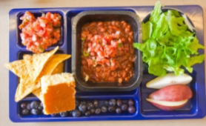
This provides farmers, school food managers and school administrators to incorporate local nutritious food into their schools and offers educational opportunities about how the student’s food is grown.
Points to Consider:
- Expand in class education opportunities for students
- Farm visits by classes
- Economic potential
- Link back to farmers’ market and direct sales

Marketing Options for Fruits and Vegetables
Table Source: Ohio State University Extension FactSheet

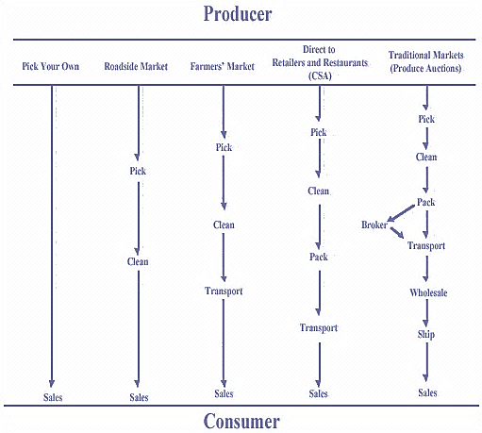
You will need:
- A business plan
- A brand
- Printed materials providing information about your farm and products.
- Understanding of the direct marketing avenue you want to use
- Types of insurance you will need (permits, packaging, labeling, pricing, supply, storage, temperature control, delivery and invoicing system)
- Honest communication
- Professional appearance
- Consistency in quality (no seconds)
- Reliability of service
- Risk taking outlook
- Pride in your product
- Willingness to plan, research and experiment
- Flexible independence & Creative thriftiness
Direct marketing enables you to become a price maker in the market, not a price taker.
It’s about networking and relationship building.

Buy Fresh Buy Local® Nebraska
Buy Fresh Buy Local® Nebraska is an education, marketing and outreach program designed to assist small to mid-scale family farmers. Visit BFBLN’s website at www.buylocalnebraska.org to learn more about local food systems.
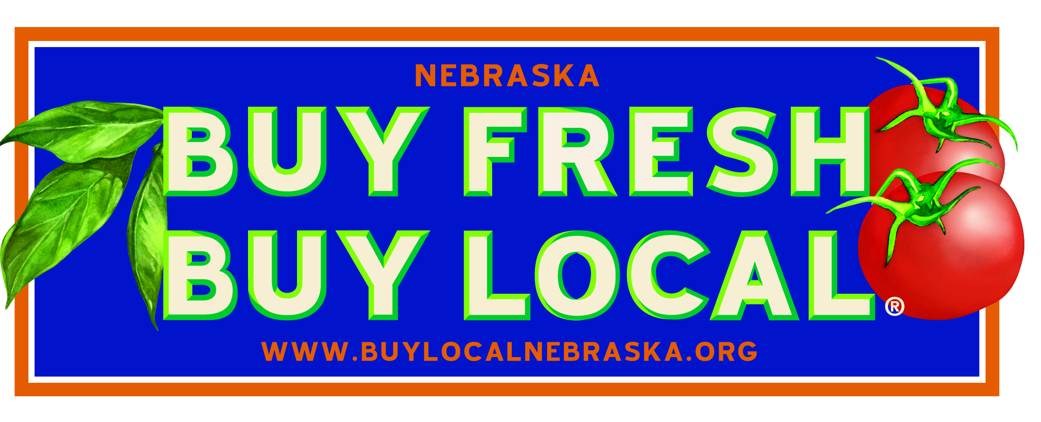
The University of Nebraska—Lincoln is an equal opportunity educator and employer.

